

**AMERICAN INTERNATIONAL UNIVERSITY- BANGLADESH**

**(AIUB)**

**Introduction to Electrical Circuit**

**FALL 2023-2024**

**Section: L, Group: 07**

**LAB REPORT ON**

***Study of Superposition Theorem***

**Supervised By**

**MD. SHAHARIAR PARVEZ**

|  |  |
| --- | --- |
| **Name** | **ID** |
| **1.MD. Abdullah** | **22-48065-2** |
| **2.Azmir Islam Kafi** | **22-47981-2** |
| **3.Mohammad Ansar Uddin** | **22-47975-2** |
| **4.Chinmoy Guha** | **22-48056-2** |
| **5.Suvra Chakraborty** | **22-48067-2** |

***Abstract:***

In accordance with the superposition principle, the current flowing through or the voltage across any component within a linear bilateral multi-source direct current (DC) circuit can be determined by examining the input from each source individually, while the other sources are substituted with their internal resistance values. The final result is established by summing up these individual contributions, taking into account their respective polarities. It's worth noting that superposition is generally not applicable to circuits with non-linear characteristics or non-linear functions, such as power.

The objective of this exercise is to-

1. Examine how the superposition theorem can be used to detect both voltage and current in various DC source circuits.
2. Examine the power.

***Circuit diagram:***

**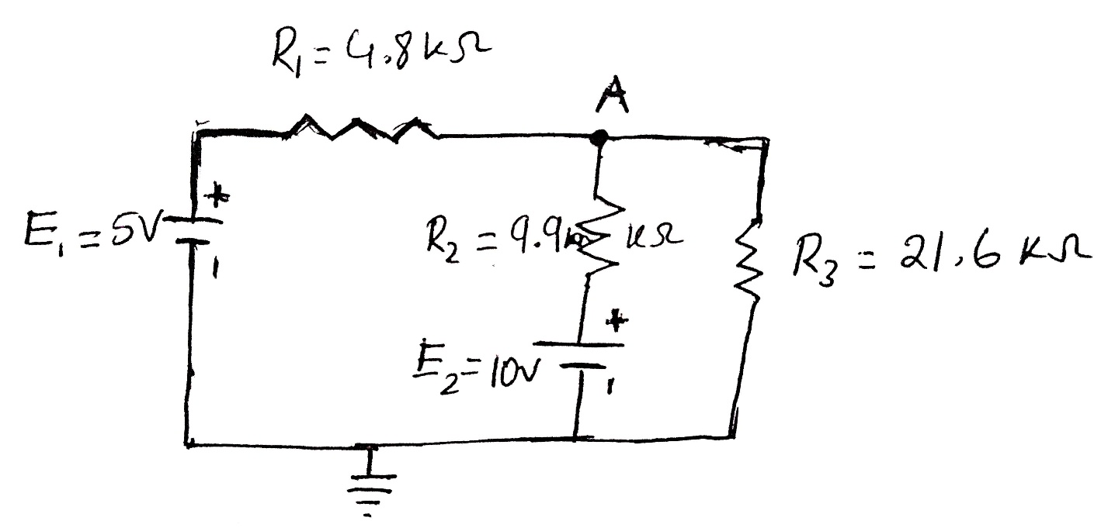 *Figure 1.***

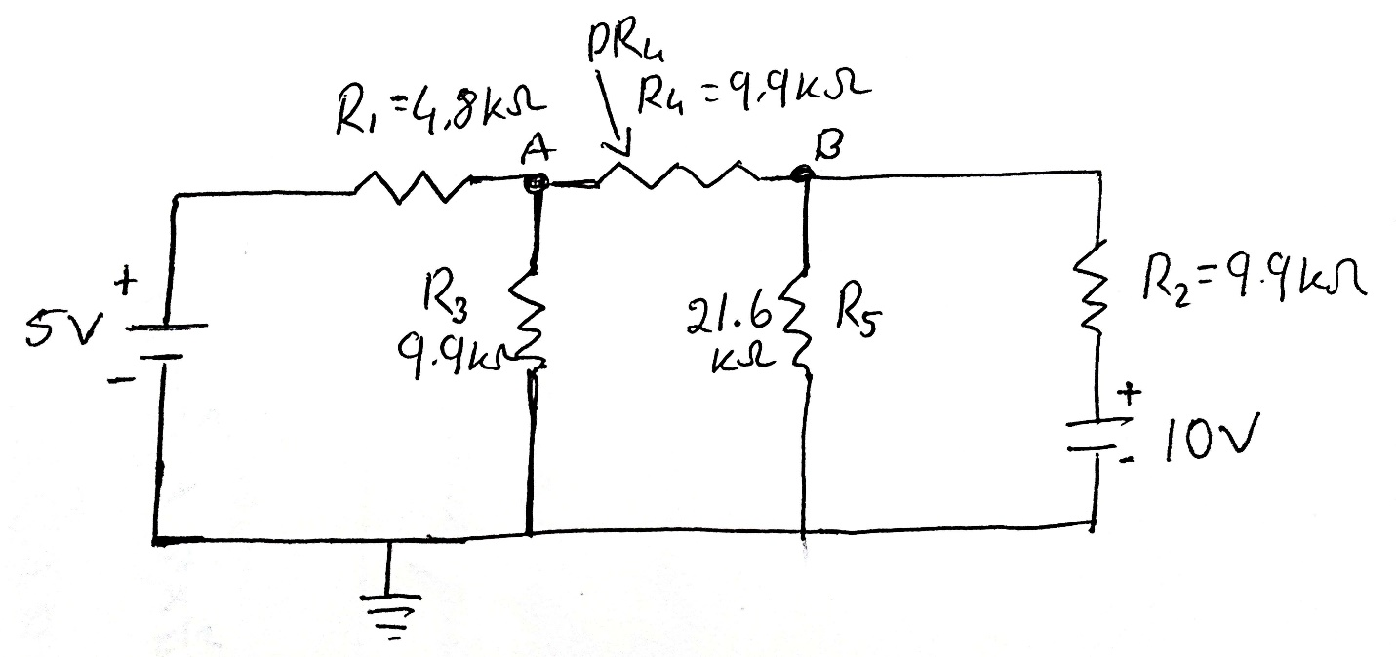

***Figure 2.***

**Apparatus:**

1. Trainer Board
2. Connecting Wires
3. Digital Multimeter
4. DC source
5. Resistors

***Experimental Procedure:***

At first, we checked whether all the apparatus is working fine or not.

We completed the implementation of the circuit depicted in Figure 1, following a series of steps. Firstly, we removed the supply voltage E2 by applying a short circuit. Next, we carefully measured the node voltage VA, taking note of its polarity. Subsequently, we restored the supply voltage E2. Following this, we repeated the process by short-circuiting the supply voltage E1 and measured the node voltage VA once again, being mindful of the polarity. After reestablishing the supply voltage E1, we performed a final measurement of node voltage VA, recording its polarity. Finally, we compiled the data in table 1 and meticulously compared the experimental results with the theoretical values, checking for any deviations.

We implemented the circuit illustrated in Figure 2 and proceeded to repeat the procedures as outlined in steps 2 to 9. During this process, we measured the IR4 current and the PR4 power across the R4 resistor while taking careful note of the direction of IR4 current flow. Subsequently, we completed both table 2 and 3, and meticulously examined the deviations between the experimental results and the theoretical values.

***Result analysis :***

**Table 1:**

|  |  |  |  |
| --- | --- | --- | --- |
| **Source** | **VA (Theory)** | **VA (Experimental)** | **Deviation** |
| E1 (5V) | 2.07 V | 2.9 V | 0.83 |
| E2 (10V) | 4.14 V | 2.26 V | 1.88 |
| E1+E2 | 6.21 V | 5.3V | 0.91 |

**Table 2:**

|  |  |  |  |
| --- | --- | --- | --- |
| **Source** | **IR4 (Theory)** | **IR4 (Experimental)** | **Deviation** |
| E1 (5V) | 0.17 mA | 0.17 mA | 0.0 |
| E2 (10V) | 0.35 mA | 0.35 mA | 0.0 |
| E1+ E2 | 0.52 mA | 0.18 mA | 0.34 |

**Table 3:**

|  |  |
| --- | --- |
| **Source** | **PR4** |
| E1 only | 0.29 mW |
| E2 only | 1.2 mW |
| E1+E2 | 0.32 mW |

***Simulation:  
  
TABLE 1:***

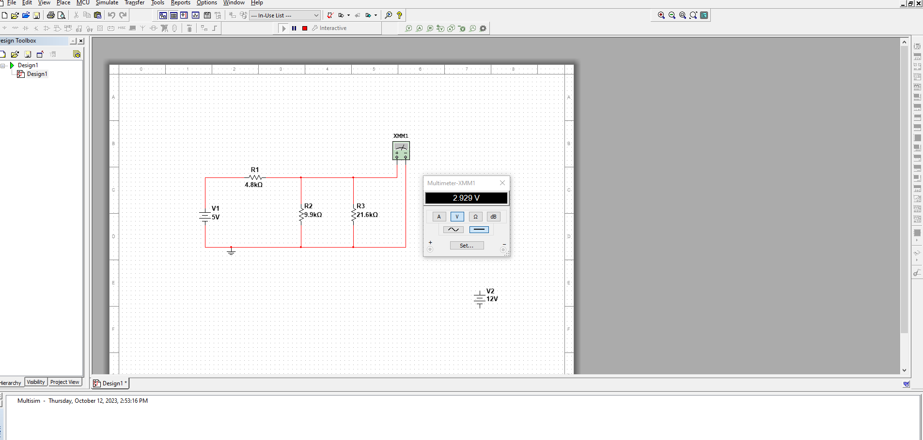

***Figure: VA for E1***

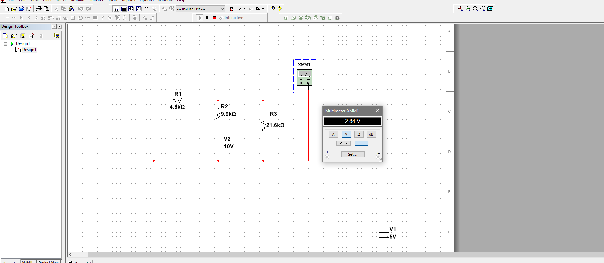

***Figure: VA for E2***

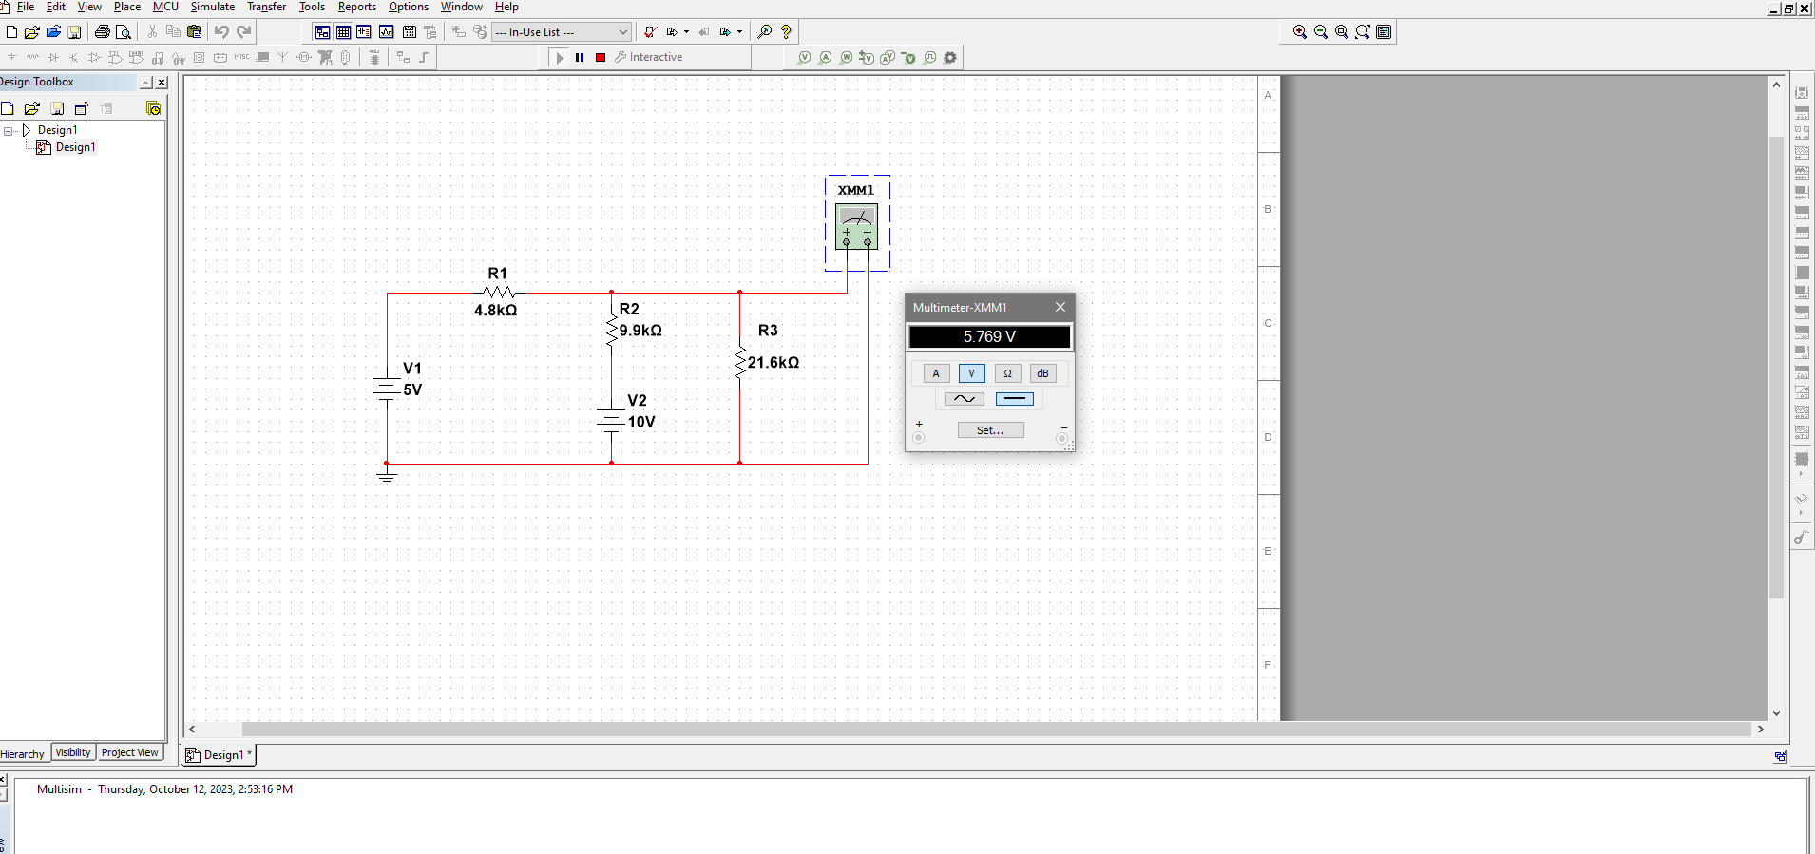

***Figure: VA for E1 & E2***

***TABLE 2:***

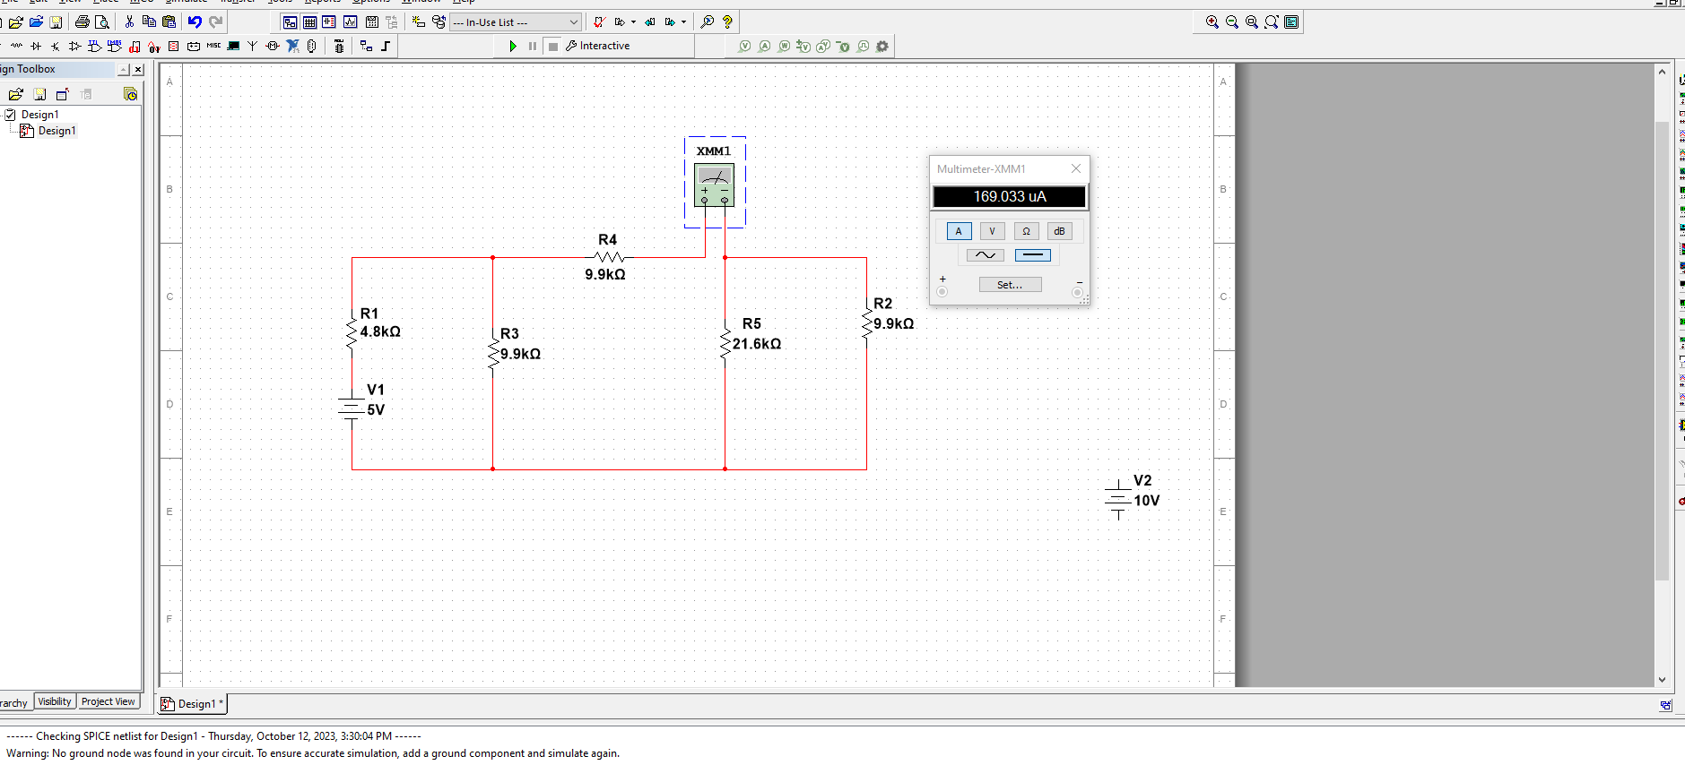

***Figure: IR4 for E1***

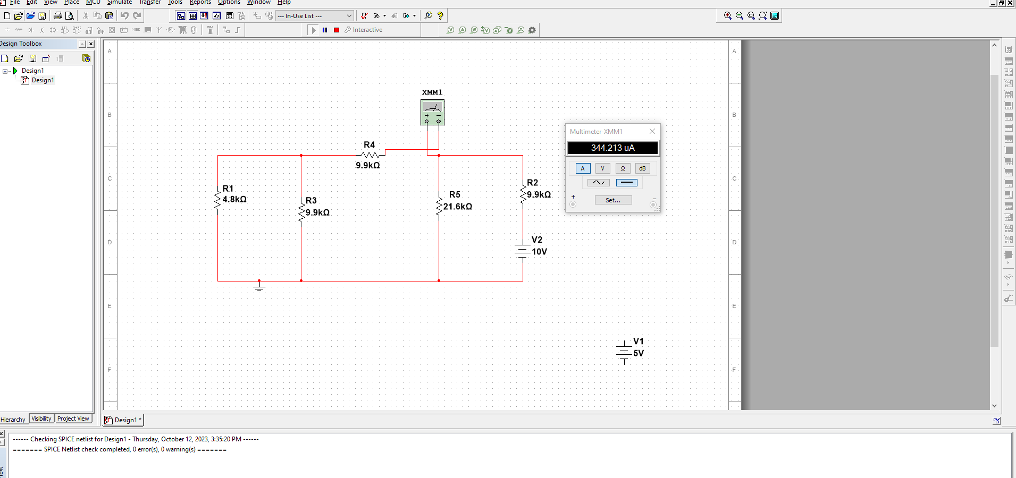

***Figure: IR4 for E2***

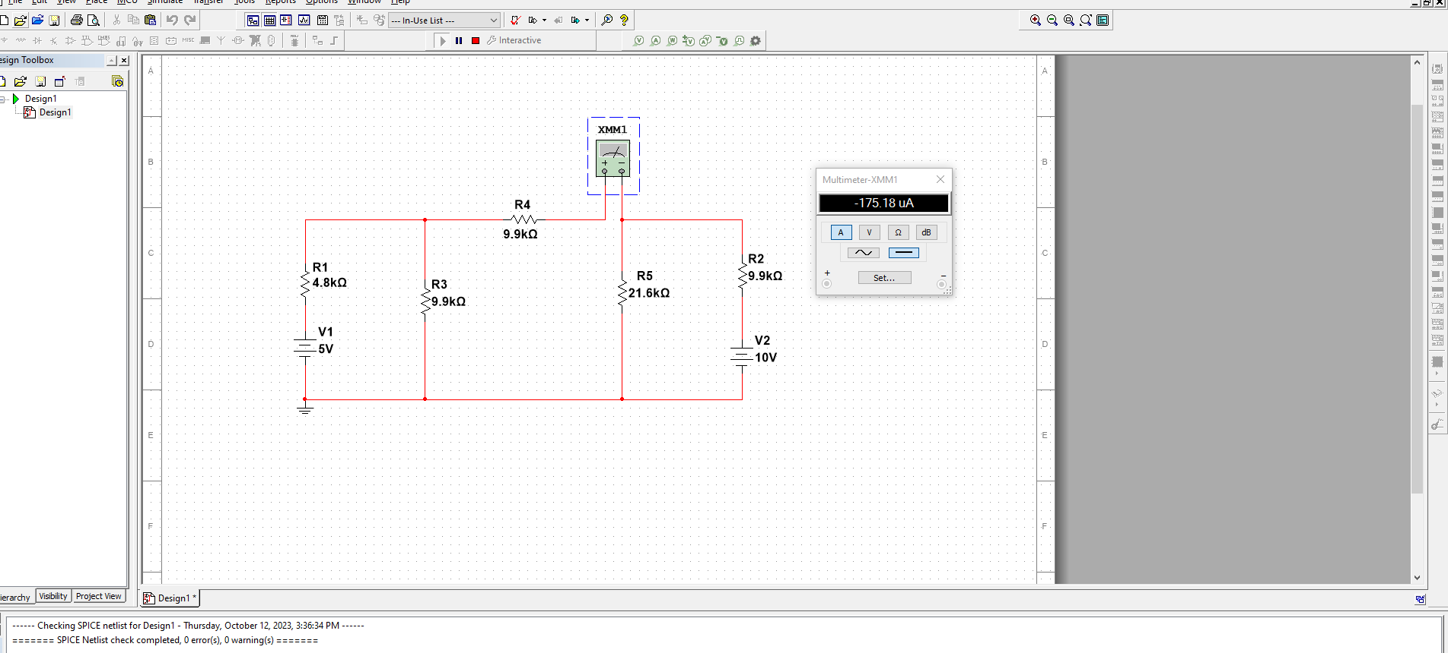

***Figure: IR4 for E1 & E2***

***Calculation:***

RT = R1+(R2||R3) = 11.588 K ohm.

I1 = E1/RT  = 0.43 mA

I2= E2/RT  = 0.86 mA

VA = I1R1 = 2.07 V for E1

VA = I2(R2||R3) = 4.14 V for E2

E1:  
Rt = 11k ohm.

I=0.45mA

IR4 = 0.17 mA for E1

E2:

Rt = 18k ohm.

I=0.56mA

IR4 = 0.35 mA for E2

PR1 = I2R4 = 0.29 mW for E1

PR1 = I2R4 = 1.2 mW for E2

***Discussion***

By comparing the calculated data with experimental data, we have observed and verified the superposition principle.

Superposition theorem only works on linear equations such as current or voltage as per the data found.

Some resistors may not be placed firmly, so measured results may have deviated from the proper results. But they are very close to each other and therefore the deviation may be ignored.

***Conclusion:***

The Superposition principle observed theoretically, practically and in simulation results.